In the file src\pages\game\components\board\Board.jsx

- string <Sprites id={cell} className="hidden-svg" />

- replace with <p classname="hidden-svg">{cell}</p>

In the file src\pages\game\components\board\Board.jsx

- string

- replace with

{cell}

This is the result (screenshot_1.png) if you change the code.

This is the result (screenshot_1.png) if you change the code I specified.

This is the result (screenshot_1.png) if you change the code I specified.

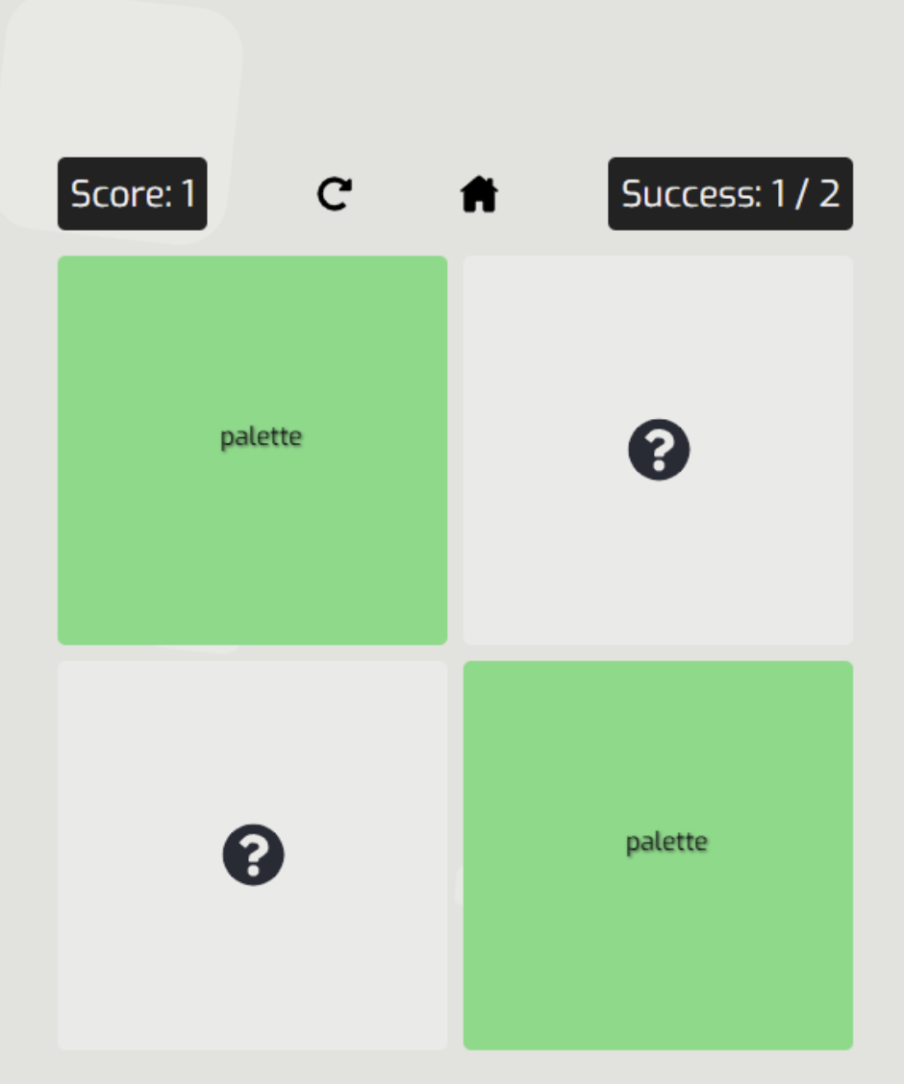

You can replace the list of words with your own in the src\store\sprites.js file

You can replace the list of words with your own in the src\store\sprites.js file

You can replace the list of words with your own in the src\store\sprites.js file